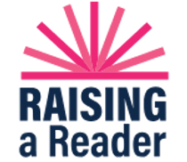

Welcome Readers!

Beginning in _____________, each **______________** your child will bring home a Red Book Bag with 3 wonderful books for your family to enjoy! Please return the red bag with the books the following **_____________.**

Another red bag with 3 different books will go home with your child each week after they have returned the previous bag.

Please read or look at the books with your child every day! Setting aside a special time- even 10 minutes each day- is wonderful way to enjoy each other’s company and to create a lifelong love of reading. It’s called “book cuddling time”.

Sharing books and reading aloud to young children is not only one of the best activities to stimulate language and cognitive skills, it also builds motivation, curiosity, and memory.

Talk about each book. Talking about books

and re-reading will

help your child

become familiar with

words and develop a

love of language. Early language and literacy

is comprised of

listening, speaking,

reading and writing.

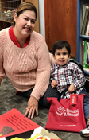

But the best part is that it is fun!

It doesn’t matter if you just read a few pages, change the

words, or just sit and talk about the pictures, your children

will experience the joy of sharing books.

Thank you for your partnership as your child develops a love of reading.

Happy Reading!

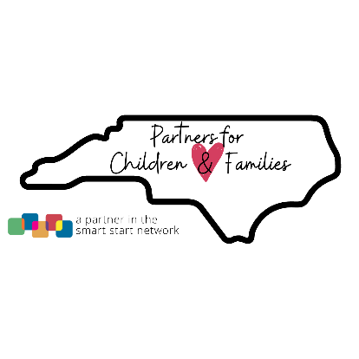

**pfcfmc.org**